(1) From the OSCAR menu, click ‘Admin’.

​
(2) Scroll down the list and click ‘Upload eForm’.

​
(3) Near the top of the window, click ‘Import eForm’.

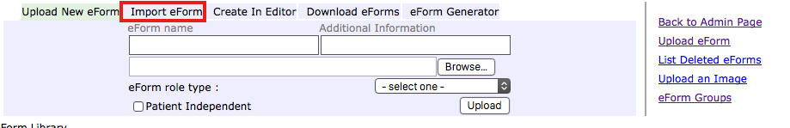
​
(4) Click ‘Browse’
​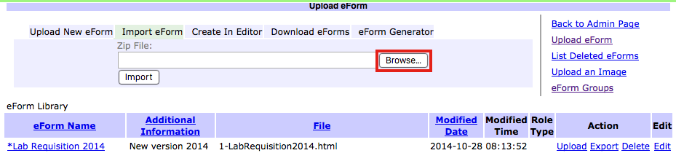

(5) Find the .zip file that you downloaded or received via email, usually located in your 'Downloads' folder.
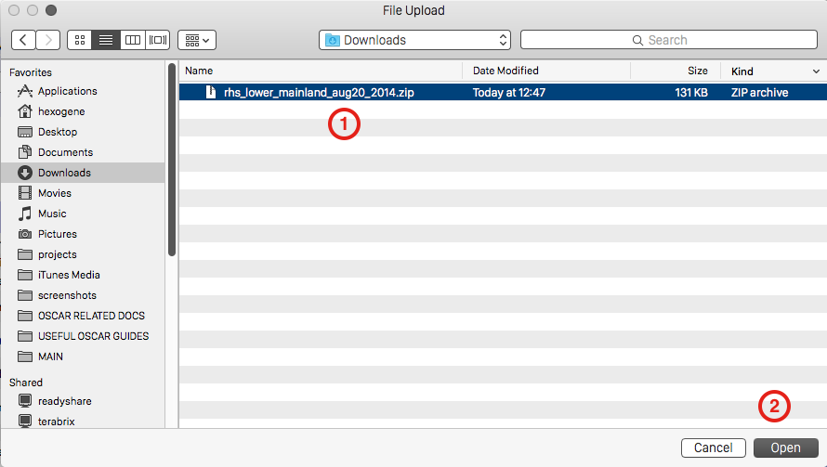
​(6) Now click the desired file once to select it, then click ‘Open’.

(7) Next, click ‘Import’.

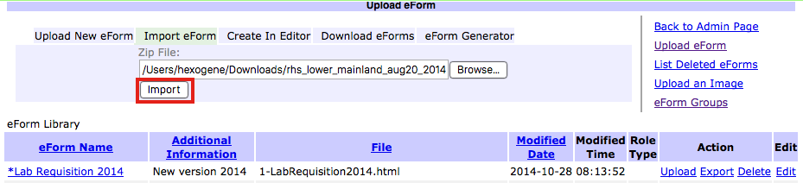
​
You may see a warning at the top, which is usually safe to ignore, however to be sure, please take a moment read and understand the message.

